Abstract for the Automation 2023

Author A¹, Author B², and Author C^{2,} *
¹First author's affiliation, City, Country
²Second author's affiliation, City, Country
³Third author's affiliation, City, Country
*Corresponding author: auto2023@ntut.edu.tw
Abstract: These instructions give you guidelines for preparing full papers for Automation 2023. Please use this document as a template to prepare your manuscript. For submission guidelines, follow instructions on paper submission system as well as the Conference website. In order to provide a consistent appearance of the manuscripts, it is important for the authors to use this template.

The abstract should contain no more than 200 words. It should indicate the techniques used and summarize the most important results. Define all symbols and abbreviation used in the abstract. Do not cite references in the abstract.

Keywords: 3 to 5 keywords or phrases in alphabetical order, separated by semicolon. For example: Automation; Smart Living Technology.

Full paper for the Automation 2023
(Maximum two rows if needed)

Author A¹, Author B², and Author C^{2,} *
¹First author's affiliation, City, Country
²Second author's affiliation, City, Country
³Third author's affiliation, City, Country
*Corresponding author: auto2023@ntut.edu.tw
Abstract: These instructions give you guidelines for preparing full papers for Automation 2023. Please use this document as a template to prepare your manuscript. For submission guidelines, follow instructions on the paper submission system as well as the Conference website. To provide a consistent appearance of the manuscripts, it is important for the authors to use this template.

The abstract should contain no more than 200 words. It should indicate the techniques used and summarize the most important results. Define all symbols and abbreviations used in the abstract. Do not cite references in the abstract.

Keywords: 3 to 5 keywords or phrases in alphabetical order, separated by semicolon. For example: Automation; Smart Living Technology.

1. Introduction
The Automation 2023 will be held in Taipei, Taiwan, from Dec. 8 to 10, 2023. The manuscript should fit A4 page size (210mm × 297mm). Margins should be set for a 2.6 cm top, a 2.2 cm bottom, and a 2.2 cm left and right. The length of the full paper should be 5-7 pages including all figures and tables. Please underline the presenting author. Please do not insert any page number, header, or footer. The manuscript includes a main body, figures, charts, and images if needed. Only manuscript that meets requirements will be considered for presentations. Please use a Time New Roman (10 pt) font. It is requested to upload the manuscript in PDF format.

2. Main text
The main text should be set in two-column format with a minimum gutter between the columns of 8 mm. Font size should be 10 pt. The first line of the first paragraph of a section or subsection should be left aligned. All submissions must be in English. The URL link of the official website of this conference is https://www.automation2023.org/. Please upload a PDF file. The size of PDF files is limited to 5 MB. Other formats, such as MS-Word, LaTex, AmiPro…etc., will NOT be accepted.

3. Figures, Photos, Tables, and Equations
Regarding figures, photos, tables, and equations, both black-and-white and colored are acceptable. Captions should be placed under the figures and the photos, and above the tables. Font size for the caption should be 10 pt. All figures and tables should be placed within the text at the appropriate points, rather than at the end.

Table 1. Sample table
λ(nm) | A. | B. | C.
400 | 100 | 0.01 | 645
500 | 200 | 0.02 | 710
700 | 300 | 0.04 | 1192
800 | 400 | 0.16 | 1860

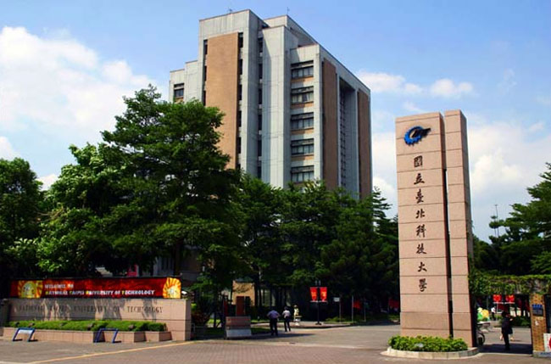
Fig.1. Sample figure for Automation 2023

Equations should be centered. The number of the equation can be given if necessary.
(1)
As with tables and equations, figures should be set in one column possible unless two-column display is essential.

4. Conclusions

Describe the conclusions of your paper concisely.

5. Acknowledgement
Acknowledgements, if needed, appear after the Conclusions.

6. References
References should be set at the end of the manuscript. The reference numbers should be consistent with the order in which they are cited in the body of the paper.
Provide the full name of the journal title and conference name.

[1] Y. S. Lu and R. Shieh, Control Eng. Pract., 28 (2014) 49–57.
[2] S. T. Chen, et al., 6th International Conference on Technological Advances of Thin Films & Surface Coatings, Singapore, 2012.
[3] S. Turner, Screen printing Techniques. New York: Taplinger, 1976. (Times New Roman, 10pt)

Deadlines
The deadline for online submission of the 5-7 pages manuscript is September 29, 2023.

File type of the manuscript
The authors should submit the manuscript as a PDF file.

